GALA DAY VENUES - WINTER

Competition Soccer – Sarah Redfern Playing Fields, Minto (Behind the High School)
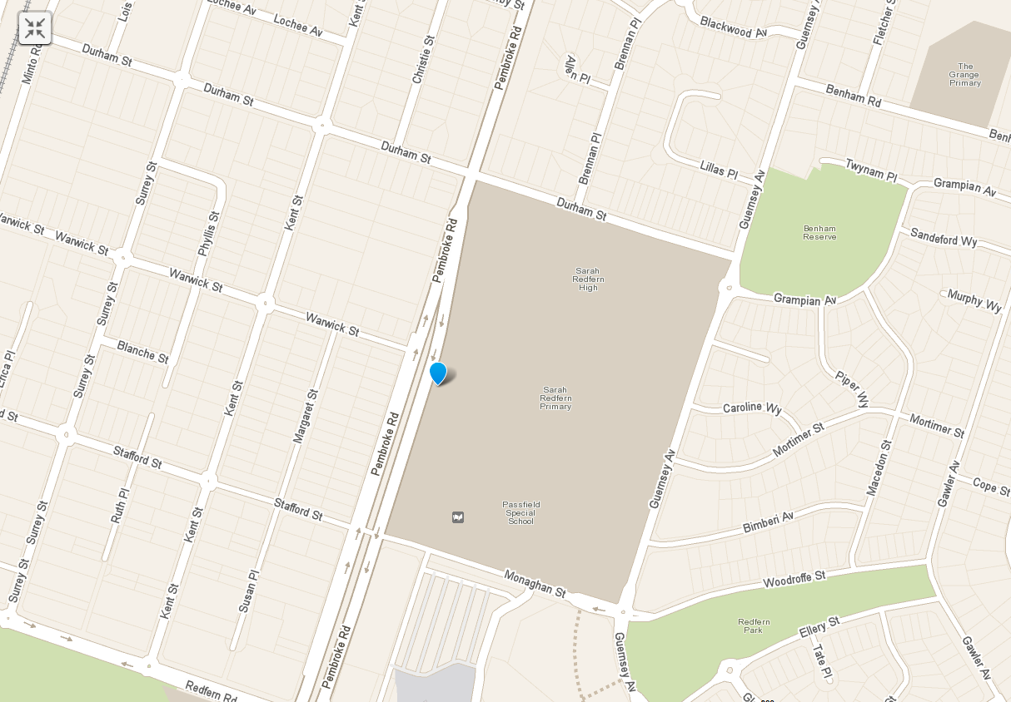

Participation Soccer - Victoria Park –
Minto Rd, Minto (behind the PCYC)
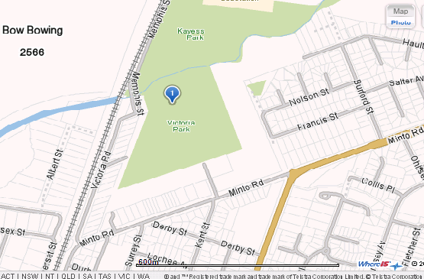

Netball and Newcombe Ball –
Coronation Park - Redfern Rd, Minto
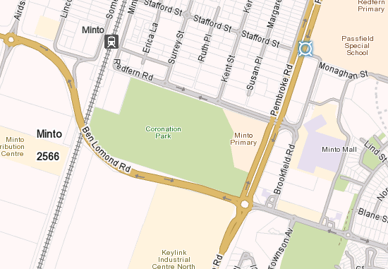

AFL – Monarch Oval, Macquarie Fields
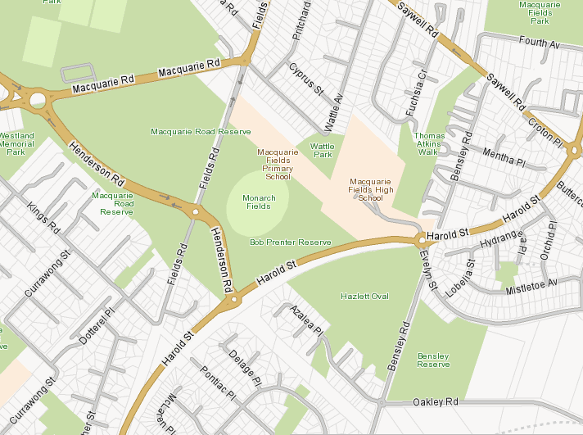

Rugby League – Kayess Park, Memphis St, Minto



